Department of Computing

**Basics, e.g. printing and Escape Sequences**

CS-110: Fundamentals of Computer Programming

Dr Nazia Perwaiz

**Learning Objectives**

After completing this section you will be able to:

1. Understand the basic structure of a C++ program
2. Do some basic printing in C++

# Lab Tasks

1. **Comments and Slashes**

Comments are very important in your programs. They are used to tell you what something does in English, and they also are used to disable parts of your program if you need to remove them temporarily. Here’s how you use comments in C++:

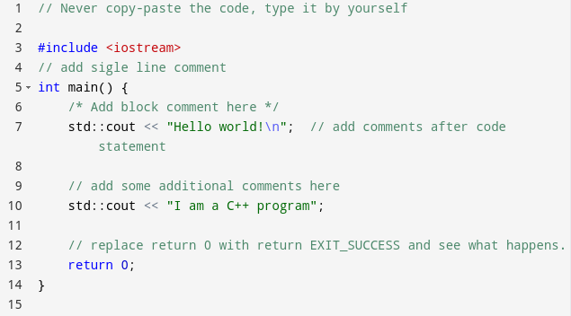

In the above code, you can replace EXIT_SUCCESS with 0.

Type, compile and execute the code.

What You Should See

**Hello World!**

**I am a C++ Program**

Now try these changes.

1. Were you right about what the two slashes (‘//’) signify? Answer in a comment at the top of the file (above the ‘#include’ lines).

1. Add another comment at the very top of the file (above your answer to the previous question) with your name and today’s date.
2. **Indentation**

Programs should be indented properly to make them easier to read:

* + - { opening brace 🡨 increase indent of the above program in task 1, by one tab
    - } closing brace 🡨 decrease indent of that line and following lines by one tab

Make sure that from this day on all your programs have good indentations.

Type, compile and run the above code with proper indentation.

1. **Escape Sequences**

An escape sequence inserts a special character into a printf statement.

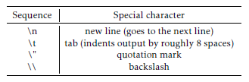

What output is produced by these codes? Type them and test them individually.

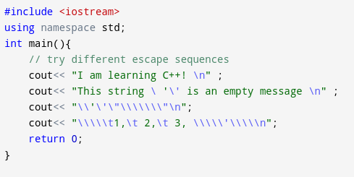

1. Write a complete C program named MuchBetter.c that produces the following output

(note the blank line):

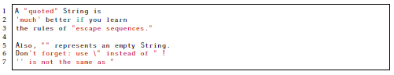

1. Write a program that displays your name and address on the screen as if it were a letter. Your output should look roughly something like that below.

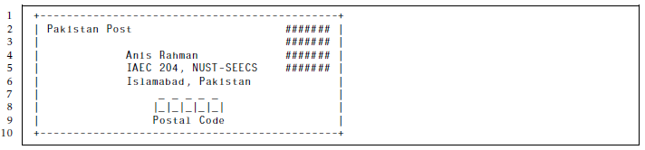

1. Write a program that prints a box, an oval, an arrow and a diamond as follows:

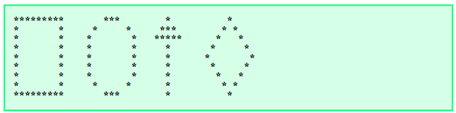

1. Write a program that prints a simple business card with name, title, company and email — use borders to frame it.